Jasdeep Singh ( 200540018)

Sukhwinder Singh (200576366 )

In Class Assignment 2

Question 1: Create a database called TransactionCompany, drop it and create it again. Check which database you are currently in.

Answer 1:

Question 2: Create a collection called Employee in TransactionCompany(created in Q1) and insert the document below.

Answer 2:   
  
Question 3: Create a collection called transactions in TransactionCompany (drop if it already exists) and load the data from a json file(using command line(, transactions.json (given below). Upload the record from the new file called transactions_upsert.json(using upload from compass) in same collection.  
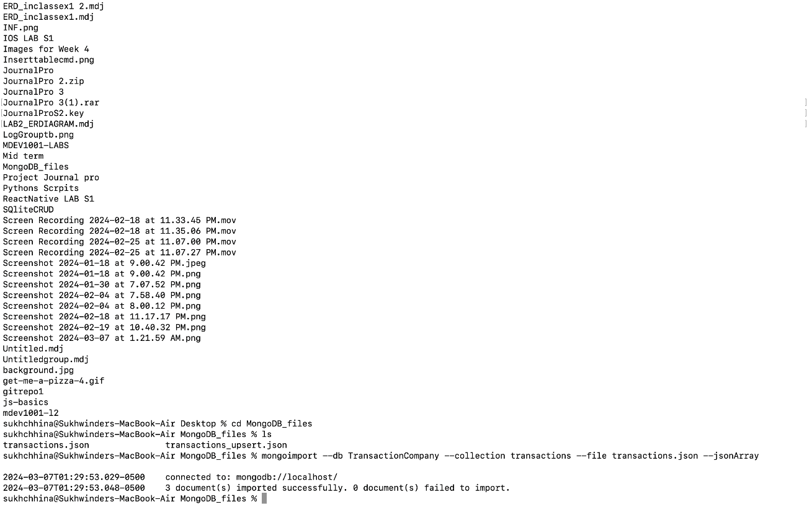

Question 4

1. Find any record where Name is Tom.

1. Find all records where Name is not Sarah.

1. Find any record where transaction id is “tran3”.  
   A screenshot of a computer

   Description automatically generated
2. Find any record where total payment amount (Payment.Total) is 400.  
   A screenshot of a computer

   Description automatically generated
3. Find any record where price (Transaction.price) is greater than 400.  
   A screenshot of a computer

   Description automatically generated
4. Find any record where Note is null or the key itself is missing.  
   A screenshot of a computer

   Description automatically generated
5. Find any record where Note exists, and its value is null.  
   A screenshot of a computer

   Description automatically generated
6. Find any record where Note key does not exist.  
   A screenshot of a computer

   Description automatically generated
7. Find the records where payment is through Credit Card type.  
   A screenshot of a computer

   Description automatically generated